CUSTOMER BEHAVIOR ANALYSIS
PROJECT REPORT
1. Executive Summary

This project explores customer behavior across product categories to uncover purchasing patterns, subscription trends, and review sentiments. The dashboard delivers actionable insights to support marketing, product strategy, and customer engagement efforts.

2. Objective

To analyze how customer demographics, subscription status, and product categories influence purchasing behavior and satisfaction, and to identify opportunities for business growth.

3. Dataset Overview

Source: Kaggle

Size: 19 rows × 3901 columns

Key Fields: Customer ID, Purchase Amount, Review Rating, Subscription Status, Gender, Product Category

4. Tools and Technologies Used
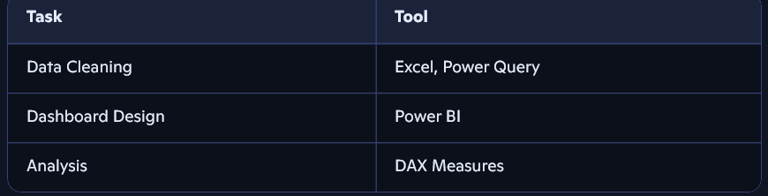

5. Data Preparation

Removed null values, duplicates, and standardized category labels

Created calculated measures:

Average Purchase Amount

Average Review Rating

Revenue by Category

Applied filters for Subscription Status, Gender, and Category

6. Dashboard Features

Top KPIs:

Total Customers: 3.9K

Avg Purchase Amount: $59.76

Avg Review Rating: 3.75

Visuals:

Pie chart: Subscription Status (Yes: 27%, No: 73%)

Bar charts: Revenue by Category

Area chart: Sales by Category

Filters:

Subscription Status

Gender

Product Category

7. Key Insights

Subscription Gap: A significant majority (73%) of customers are non-subscribers, indicating untapped potential for loyalty programs.

Category Dominance: Clothing leads in revenue generation, followed by Accessories, suggesting strong customer preference.

Moderate Satisfaction: An average review rating of 3.75 points to areas for improvement in product quality or service experience.
output :
